Proud of Our School

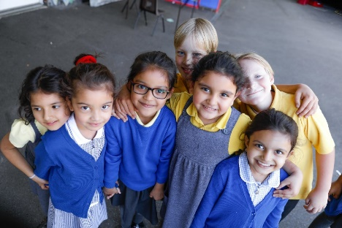

We’re proud of our school, no school is the same
We’re proud of the name, it’s called Barley Lane.
And this is the song, the song that we sing,
As we are all part of this wonderful thing.


Everybody’s here at Barley Lane
Everybody knows it’s a marvellous place.
Everybody’s proud to call this school our school.
Everybody’s proud to call this school our school.

We’re on Huxley Drive, our rule is Be Kind!
We all play a part, we all use our mind
And when it’s our turn we give it our all,
As we are all part of a compassionate school.
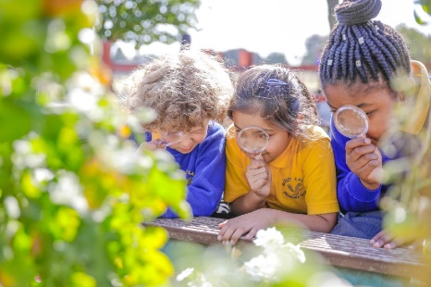

Everybody’s here at Barley Lane
Everybody knows it’s a marvellous place.
Everybody’s proud to call this school our school.
Everybody’s proud to call this school our school.

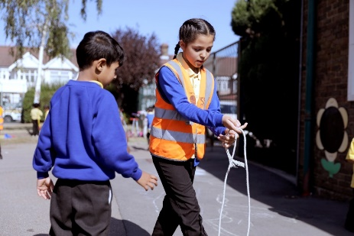
Everybody’s here at Barley Lane
Everybody knows it’s a marvellous place.
Everybody’s proud to call this school our school.
Everybody’s proud to call this school our school.



